
AFRO HR
Enterprise System Solution Blueprint
File 00 — Executive Overview, Vision, Objectives & Scope
Target-State Product Definition
People & Culture • Field Workforce • Payroll • Talent • Employee Services • Analytics • AI
Prepared for | AFRO Group
Document ID | AFRO-HR-SSB-00
Version / Status | 1.0 / Draft for Review
Date | 10 August 2026

0. Document Control & Source Basis
This file defines the executive-level target state. Detailed requirements are intentionally deferred to the subsequent blueprint files.

Document Control
Field | Value
Document Title | AFRO HR — Enterprise System Solution Blueprint — File 00
Document ID | AFRO-HR-SSB-00
Version | 1.0
Status | Draft for Review
Primary Audience | Executive Management, People & Culture, IT, Program Team, Solution Design, Implementation Partners
Purpose | Define product vision, strategic objectives, high-level scope, system boundaries, success measures and design direction.
Language | English master version; the target product supports English, Arabic (RTL) and French.

Source Basis and Evidence Rule
Current-state sources. The People & Culture Operations Manual is treated as the authoritative source for the documented current workflows in hiring, onboarding, offboarding, payroll, allowances, KPI bonus and HR Operations. The People & Culture organization chart is treated as the source for the current functional reporting structure.
The target-state system described in this blueprint is broader than the two source documents. Where a capability is not explicitly documented in the source manual, it is presented as a target-state design requirement from the AFRO HR program rather than as a claim about the current operating process.

Approval / Review Roles
Role | Review Focus | Status
Executive Sponsor / CEO | Strategic fit, investment direction, enterprise scope | Pending
People & Culture Manager | Business scope, process ownership, policy alignment | Pending
IT / Technology Owner | Architecture, security, hosting, integration feasibility | Pending
Program / Product Owner | Priorities, MVP boundaries, release plan | Pending

0.1. Contents & Reading Guide
Section | Content
1 | Executive Summary
2 | Business Context & Case for Change
3 | System Vision & Product Positioning
4 | Strategic Objectives
5 | Target-State Design Principles
6 | Scope Model & Functional Domains
7 | Twenty-Module Portfolio
8 | System Boundaries & Out-of-Scope
9 | Users, Roles & Experience Channels
10 | End-to-End Employee Lifecycle
11 | Shared Platform, Automation & AI
12 | Integration & Data Ecosystem
13 | Success Measures & Governance
14 | Assumptions, Constraints & Key Risks
15 | Key Decisions & Next Blueprint Files
Appendix | Glossary and source references

How to Use This File
- Executives should focus on Sections 1–6, 8, 13 and 15 to confirm why the system is being built, where its boundaries are and how success will be measured.
- People & Culture process owners should confirm the functional domains, lifecycle coverage and operating principles before detailed module requirements are approved.
- Technology teams should treat Sections 5, 11 and 12 as direction-setting only; detailed architecture, security and integration specifications will be produced in later files.
- Any statement marked “working title”, “to be confirmed” or “target-state extension” is an explicit design item that still requires formal validation.
Scope discipline. This file is not the SRS and does not replace detailed functional requirements, workflow specifications, data models, interface contracts, security matrices or UAT cases.

1. Executive Summary
AFRO HR is defined as an enterprise People & Culture operating platform, not only an employee database or payroll utility.
The current People & Culture manual already defines structured operating cycles for hiring, onboarding, offboarding, payroll, allowances, KPI incentives and HR Operations. These processes cross Talent Acquisition, Personnel, Payroll, HR Operations, HSE, IT, Finance, Administration, project management and direct managers. The target platform will convert those lifecycle processes into governed digital workflows with a controlled employee master record, auditable approvals, policy-driven calculations and role-based services.
The target state extends beyond the current manual into a full HR platform covering organization design, identity and permissions, attendance, leave, compensation, performance, learning, career and succession, employee relations, HR service management, personnel compliance, analytics, engagement, governance and organization development.
One Employee Record  A single governed source of truth across the employee lifecycle. | Workflow-Driven  Approvals, SLAs, evidence and exceptions are controlled in-system. | Field-Workforce Ready  Supports projects, sites, shifts, GPS, devices and supervisors.
Payroll-Controlled  Payroll consumes validated inputs and preserves calculation traceability. | Multi-Language  English, Arabic RTL and French at user and configuration level. | AI-Assisted  Copilot and agents support decisions without bypassing human controls.

Executive Outcome
Target outcome. Management should be able to answer “Who works for us, where are they assigned, are they ready and compliant, what do they cost, what decisions are pending, what risks are emerging, and what action is required?” from one governed platform.

2. Business Context & Case for Change

Current-State Foundation
The documented operating model is already process-oriented. Hiring is defined from manpower request through sourcing, assessment, offer and handover to Personnel. Onboarding continues through document collection, contracting, system registration, equipment readiness, HSE requirements, orientation and employment activation. Offboarding covers access deactivation, handover, clearance, legal and financial closure, and file archiving.
Payroll, allowances and KPI incentives are operated through recurring validation, calculation, submission, payment and project cost reporting cycles. HR Operations then supports project assignment, operational readiness, workforce management, employee relations, investigations, compliance follow-up and resignation coordination.

Why a System Layer Is Required
1. Process continuity: lifecycle stages should pass structured data and approvals to the next stage instead of being re-keyed or re-confirmed manually.
2. Data ownership: employee, position, project, compensation, attendance, document and compliance data need explicit owners and controlled history.
3. Operational control: SLAs, pending approvals, missing documents, expiring requirements and payroll-impacting exceptions must be visible before they become failures.
4. Project workforce visibility: project-based staffing requires assignment history, cost allocation, deployment readiness and manager visibility.
5. Compliance and auditability: sensitive employment decisions and payments must be traceable to approved inputs, roles, policies and evidence.
6. Management information: executives need consistent headcount, people cost, workforce readiness and risk metrics from governed data rather than disconnected reports.

Current-State to Target-State Shift
Current Operating Need | Target System Response
Cross-department handoffs | Workflow cases with ownership, status, SLA and audit trail
ERP / email / trackers used at different stages | Unified HR process layer with controlled integration to external systems
Project and site workforce | Multi-project assignment, location, roster and field attendance controls
Monthly payroll cutoffs | Locked payroll runs fed by approved attendance, leave, allowances, KPI and adjustments
Document and certification follow-up | Expiry rules, alerts, readiness gates and compliance dashboards

3. System Vision & Product Positioning

Vision Statement
AFRO HR Vision. Create one secure, configurable and auditable People & Culture platform that governs every material employee-lifecycle event — from workforce demand and recruitment through deployment, pay, development, employee service and separation — while remaining practical for both office and telecom field operations.

Product Positioning
AFRO HR is positioned as the People & Culture system of engagement and process control. It will own HR workflow, employee lifecycle state, HR-specific rules, evidence, approvals and HR analytics. It will not replace Finance, banking, customer operational platforms, corporate identity services or a full HSE management system; instead, it will exchange governed data with them.

What Makes the Target Product Different
- Telecom contracting and project-workforce orientation, including project assignment, site/location rules, field attendance and deployment readiness.
- Multiple attendance evidence methods: biometric devices, GPS/mobile, supervisor validation and controlled manual evidence.
- Payroll and allowance rules capable of project allocation, overtime, location/field allowances, KPI bonus and approved adjustments.
- Strong personnel and compliance controls covering contracts, insurance, documents, certifications, medical/HSE readiness and expiry monitoring.
- Multi-company and SaaS-ready architecture with tenant isolation and configurable company policies.
- Employee and manager self-service with mobile support for field roles.
- An AI layer designed for search, explanation, recommendations, drafting and controlled actions with human approval where required.

North-Star User Experience
A user should not need to understand the underlying HR modules to complete routine work. The system should present the next valid action, required evidence, approval path, SLA and policy rule based on the employee, role, project, location and transaction context.

4. Strategic Objectives
Objective | Definition
O1 — Establish a Trusted HR System of Record | Create a controlled employee, position, assignment and employment history that downstream processes can rely on.
O2 — Digitize End-to-End Employee Lifecycles | Move hiring, onboarding, attendance, leave, payroll inputs, employee services, development and offboarding into measurable workflows.
O3 — Improve Payroll and People-Cost Control | Ensure earnings, deductions, allowances, overtime, KPI incentives and project allocations are based on validated and approved data.
O4 — Support Field and Project Workforce Operations | Handle project/site assignment, mobile attendance, shifts, supervisors, HSE readiness, location rules and operational deployment.
O5 — Strengthen Compliance and Audit Readiness | Track approvals, documents, contracts, insurance, certificates, cases, changes, access and policy exceptions with evidence and history.
O6 — Improve Employee and Manager Service | Provide self-service requests, letters, leave, profile updates, approvals, notifications and case visibility through role-appropriate channels.
O7 — Enable Management Decision Support | Provide reliable headcount, cost, capacity, performance, attrition, compliance, recruitment and workforce-planning analytics.
O8 — Create a Configurable Platform | Allow authorized administrators to manage rules, workflows, calendars, languages, templates, number sequences, SLAs and notifications without code changes where practical.
O9 — Prepare for External Integrations and Scale | Provide stable APIs, event patterns, reconciliation and integration monitoring for ERP, devices, banks, insurance, identity and customer systems.
O10 — Apply AI Safely to HR Work | Use AI to reduce repetitive work and improve insight while preserving access control, privacy, explainability, audit and human decision rights.

5. Target-State Design Principles
Principle | System Implication
1. One source of truth per data domain | Each critical data element has one authoritative owner; copies are synchronized, not independently edited.
2. Position, employee and assignment are separate | The organization design exists independently of a person; employees can move across positions/projects while history remains intact.
3. Workflow before informal handoff | Approvals, rejections, returns, escalations and SLA timers occur inside governed workflows.
4. Configuration before customization | Policies, rules, calendars, approvals, allowances and templates should be configurable where business variation is expected.
5. Approved inputs before payroll | Payroll reads normalized, validated payroll inputs — not uncontrolled raw attendance or ad-hoc spreadsheets.
6. Evidence for sensitive actions | Attendance overrides, pay changes, disciplinary decisions, exceptions and offboarding clearances require evidence and approval as defined by policy.
7. Least privilege and privacy by design | Users see only the employee population and data fields required by their role, company, project and responsibility.
8. Mobile-friendly field execution | High-frequency field tasks must work well on Android and tolerate variable connectivity where requirements justify offline behavior.
9. Audit by default | Material changes record who, what, when, previous value, new value, source, approval and reason.
10. Multilingual by design | Labels, templates, notifications and user experience support English, Arabic RTL and French without duplicating core business logic.
11. API-first external integration | External systems exchange data through governed interfaces with monitoring, retry, reconciliation and error ownership.
12. Human-controlled AI | AI may recommend, draft, explain and perform allowed actions, but cannot bypass permissions, approvals or policy gates.

6. Scope Model & Functional Domains
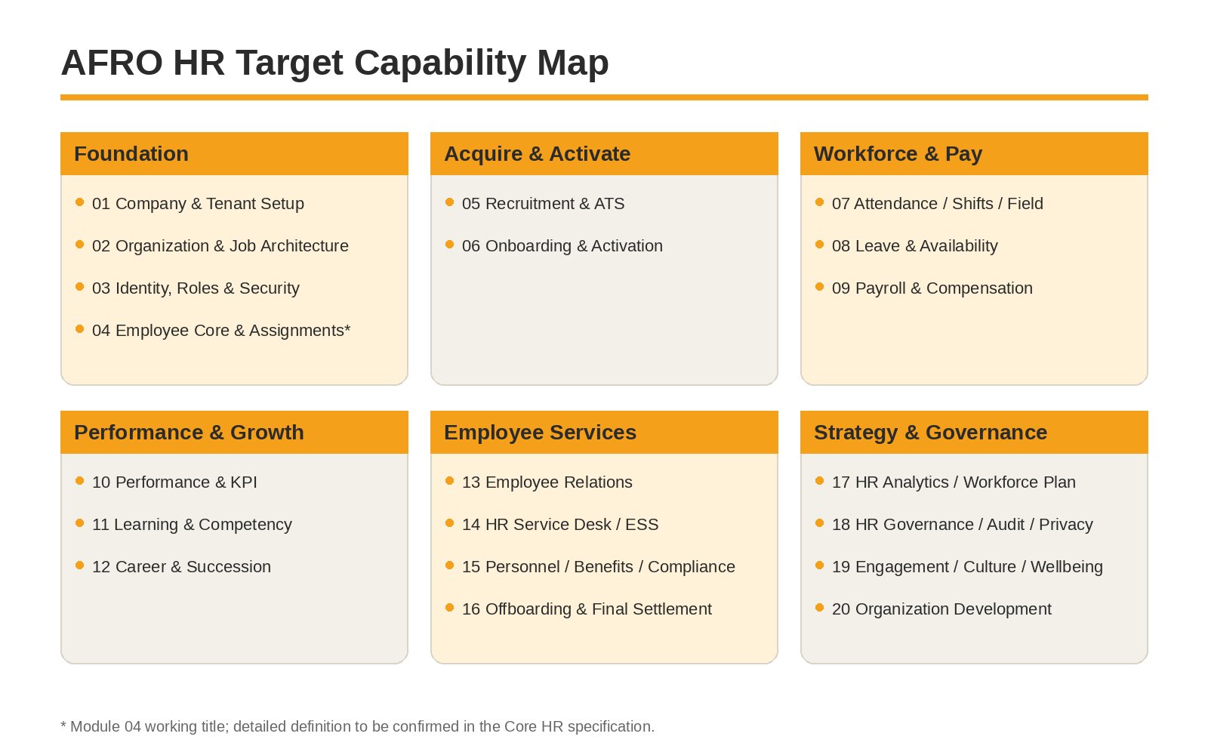
Scope interpretation. The six groups above are presentation groupings only. Detailed process ownership, data ownership and release sequencing may cross these boundaries. The numbered modules remain the primary functional decomposition for the blueprint.

Extended Capability Domains
The target platform also includes enabling capabilities that cut across multiple modules: benefits administration, occupational health/HSE employee readiness, expense and travel, HR master-data migration and integrations, and a system administration/configuration center. These are treated as cross-cutting or sub-domain capabilities rather than additional numbered modules in this blueprint.

7. Twenty-Module Portfolio — Modules 01–10
No. | Module | Executive Scope
01 | Master Company Setup | Companies, legal entities, business units, calendars, locations, projects and foundational master data.
02 | Organization Structure & Job Architecture | Organization units, positions, jobs, grades, reporting lines, workforce structure and job architecture.
03 | Identity, Users, Roles, Permissions & Security | User lifecycle, role-based access, scoped permissions, authentication controls and security administration.
04 | Employee Core, Employment Lifecycle & Assignment Management* | Employee master, employment records, position/project assignments, status history, movements and core lifecycle state.
05 | Recruitment, Manpower Request & ATS | Manpower demand, requisitions, sourcing, candidate management, interviews, assessments, approvals and offers.
06 | Onboarding, Pre-Employment Compliance & Employee Activation | Documents, contracting, systems, equipment, HSE readiness, orientation and activation gates.
07 | Attendance, Time, Shifts, Rosters & Field Workforce Tracking | Biometric/GPS/supervisor/manual evidence, shifts, rosters, exceptions, overtime and field/location rules.
08 | Leave, Absence, Holidays & Employee Availability | Leave policies, balances, approvals, calendars, absences and workforce availability.
09 | Payroll, Compensation, Earnings, Deductions & Payroll Processing | Compensation structures, payroll inputs, taxes/social insurance, allowances, deductions, payroll run and payments.
10 | Performance, KPI, Objectives, Appraisals & Incentives | Objectives, KPI cycles, reviews, scoring, calibration, incentives and performance records.
* Working title. Module 04 was not formally named in the source manual; this working title reflects the Core Employee / Position / Assignment domain already required by the target data architecture. It will be confirmed in the Core HR specification.

7.1. Twenty-Module Portfolio — Modules 11–20
No. | Module | Executive Scope
11 | Learning, Training, Competency Development & Certification | Training plans, courses, competency profiles, skill gaps, certifications and readiness.
12 | Career Management, Talent Review, Succession, Promotions & Mobility | Talent reviews, succession, career paths, readiness, promotions and internal transfers.
13 | Employee Relations, Grievances, Disciplinary Actions, Investigations & Cases | Confidential case management, evidence, investigation workflow, decisions, appeal and controlled payroll/performance impacts.
14 | HR Service Desk, Employee Requests, Letters, Documents & ESS | Employee service catalog, requests, SLA, letters, certificates, status tracking and self-service.
15 | Employee Documents, Contracts, Personnel, Insurance & Compliance | Personnel system of record, contracts, legal documents, social/medical insurance, benefits eligibility and expiry compliance.
16 | Offboarding, Resignation, Termination, Clearance & Final Settlement | Separation case, handover, access shutdown, asset recovery, clearance, final settlement and archival.
17 | HR Analytics, Workforce Planning, People Cost & Headcount Budgeting | Executive analytics, workforce demand/capacity, people cost, budgets, trends and forecasting.
18 | HR Governance, Policies, Delegation, Audit, Compliance, Privacy & Risk | Policy registry, delegation, approvals, controls, audit, privacy obligations and HR risk management.
19 | Employee Engagement, Surveys, Recognition, Communication, Culture & Wellbeing | Engagement surveys, recognition, communications, cultural initiatives, feedback and wellbeing activities.
20 | Strategic Organization Development, Organization Design & Workforce Transformation | Org design scenarios, spans/layers, operating-model changes, workforce transformation and organizational effectiveness.

8. System Boundaries & Out-of-Scope

In Scope at Platform Level
- People & Culture master data, lifecycle transactions, approvals, policy rules, documents, employee cases, readiness and HR analytics.
- Employee, manager and HR self-service; role-based dashboards; web and mobile user experiences.
- Workflow, rules, notifications, document generation, audit, localization, integration monitoring and AI assistance.
- HR-relevant project assignment, cost allocation, attendance/availability and workforce-readiness data.
- Controlled interfaces to enterprise and external systems required to complete HR processes.

Explicitly Outside the Core Product Boundary
External Domain | Boundary Rule
General ledger / full accounting | AFRO HR produces payroll, people-cost and approved financial interface outputs; Finance remains the accounting system of record.
Procurement and warehouse management | HR may request or track employee-issued assets/PPE, but full procurement, inventory valuation and warehouse operations remain external.
Enterprise project management | HR stores project identifiers and workforce assignments; project schedule, construction progress, BOQ and commercial delivery are not HR functions.
Full HSE management system | HR manages employee medical fitness, training/certification readiness and incident employee impact; enterprise hazard/permit/HSE operations remain external.
Banking platform | AFRO HR prepares approved payment data and reconciliation status; payment execution remains through Finance/banking channels.
Corporate identity platform | HR initiates joiner/mover/leaver access requirements; AD/SSO/email remains the identity infrastructure.
CRM / Sales / Customer Operations | Customer/project references may be synchronized for workforce assignment, but customer commercial processes remain outside HR.
Boundary principle. “Out of scope” does not mean “disconnected.” Where HR outcomes depend on another enterprise system, AFRO HR will define the required interface, ownership, trigger, reconciliation and exception process.

9. Users, Roles & Experience Channels

Primary User Communities
User Community | Typical Responsibilities in AFRO HR
Executive Management | Headcount, people cost, risk, workforce capacity, strategic approvals and organization decisions.
People & Culture Management | Policy ownership, process oversight, workforce controls, approvals, analytics and exceptions.
Talent Acquisition | Manpower requests, candidate pipeline, interviews, offers and hiring handover.
Personnel / Payroll / HR Operations / ER / OD | Specialist operational processing within controlled role and data boundaries.
Department / Project / Direct Managers | Team requests, approvals, attendance/leave review, deployment, performance, workforce planning and handover.
Employees | Profile, requests, leave, documents, payslips, letters, notifications, learning and case/service interactions.
Field Technicians / Supervisors | Mobile attendance, roster, project/site assignment, evidence capture, approvals and field readiness.
IT / HSE / Finance / Administration | Cross-functional tasks triggered by HR workflows, limited to required data and actions.
Candidates / External Parties | Candidate portal and controlled data exchange where applicable.

Experience Channels
Web HR Workspace  Full specialist and administrative processing. | Manager Self-Service  Approvals, team visibility and workforce actions. | Employee Self-Service  Personal services, requests, documents and notifications.
Android Field App  Attendance, field tasks, evidence and operational actions. | Candidate Experience  Applications, interviews, offers and pre-joining tasks. | AI Copilot  Permission-aware search, explanation, drafting and controlled actions.
Access principle. Role alone is not enough. Final access decisions should consider tenant/company, business unit, project, reporting line, employee population, data sensitivity and transaction context.

10. End-to-End Employee Lifecycle
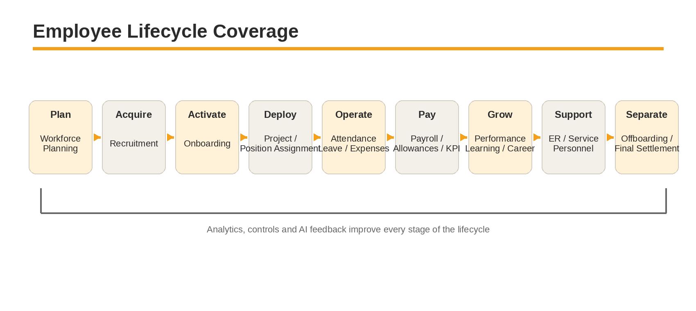

Lifecycle Control Points
- A manpower demand should reference an approved organization/project requirement before recruitment starts.
- A candidate becomes an employee only after approved offer, required documentation and employment setup conditions are met.
- Deployment to safety-sensitive work must be gated by applicable medical, HSE, certification and customer readiness requirements.
- Attendance, leave, overtime, allowances and KPI outcomes should become normalized payroll inputs only after the appropriate approvals and validations.
- Performance and competency outcomes should feed development, career and succession decisions without silently changing payroll or employment status.
- Separation should deactivate access, recover assets, close liabilities, calculate final settlement and archive the employee record through one controlled case.
Lifecycle design rule. Every major lifecycle event should create a dated, auditable state transition rather than overwrite history. This is critical for payroll, legal compliance, reporting and employee-movement analysis.

11. Shared Platform, Automation & AI

Shared Engines
Shared Capability | Executive Purpose
Workflow Engine | Reusable approvals, tasks, branching, SLA timers, escalation, delegation and versioned process definitions.
Rules Engine | Eligibility, allowances, overtime, leave, payroll inputs, readiness gates, approval thresholds and policy conditions.
Document & Template Engine | Contracts, offers, letters, acknowledgments, forms and localized templates with controlled versions.
Notification Engine | Email, in-app, mobile push and future messaging channels using event-based templates and escalation rules.
Audit & Evidence Engine | Immutable material-event trail with actor, timestamp, source, before/after value, reason, evidence and approval.
Localization Engine | Language packs, RTL/LTR, local calendars, formats, labels and template variants.
Analytics & Reporting Layer | Operational dashboards, executive metrics, drill-down, exports and governed semantic definitions.
Integration Layer | APIs, scheduled interfaces, events, retries, reconciliation, monitoring and error ownership.
AI Platform | Model gateway, permissions, prompt registry, tool access, guardrails, evaluation, cost control and audit.

AI Operating Boundary
AI is a capability layer, not a separate source of authority. It may retrieve permitted HR data, summarize records, explain rules, draft documents, detect patterns, recommend actions and execute explicitly allowed low-risk tools. Sensitive employment, compensation, disciplinary, access and separation decisions remain subject to configured permissions and human approval.
AI control principle. No AI action may bypass RBAC, workflow approval, policy validation, privacy rules or audit requirements. AI output must be attributable to the underlying data and logged when it materially influences a business action.

12. Integration & Data Ecosystem
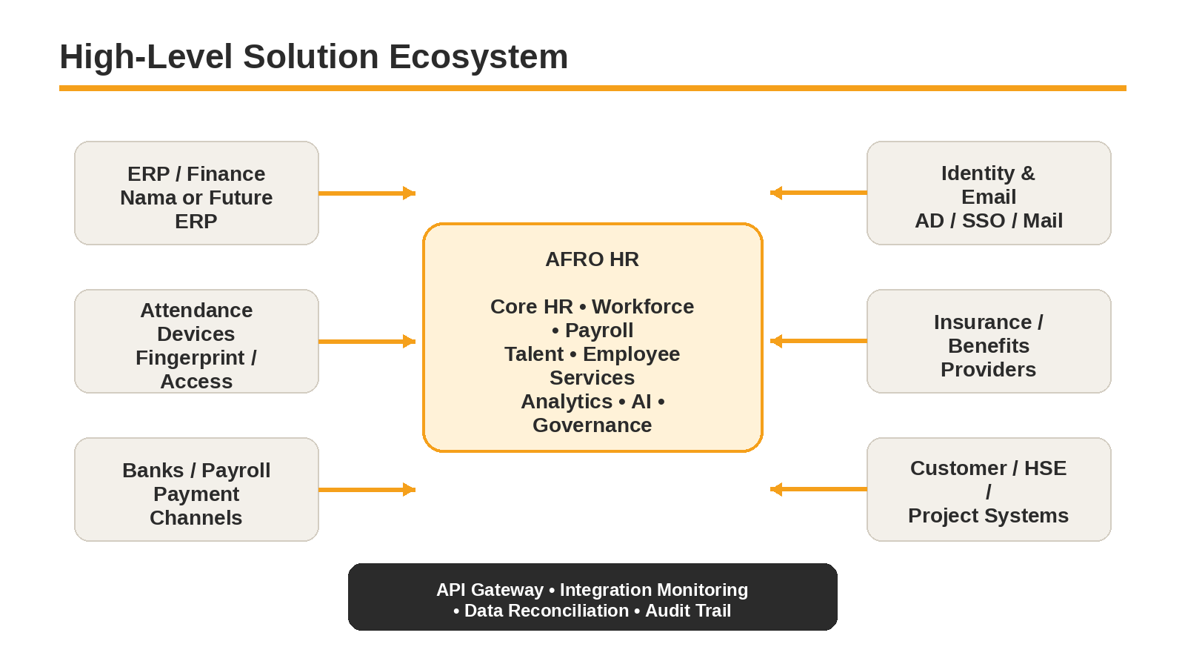

System-of-Record Governance
Data / Transaction | Expected Authority
Employee HR master and lifecycle state | AFRO HR
Organization, positions and HR assignments | AFRO HR, with controlled references to project/customer masters as required
Accounting postings and financial ledger | Finance / ERP
Bank transfer execution | Finance / Bank
Raw biometric events | Attendance device/platform; AFRO HR stores normalized attendance results and evidence references
Corporate authentication / mailbox | Identity / IT platform
Insurance provider membership confirmation | Provider/external system with AFRO HR maintaining employee eligibility and enrollment status
Integration requirement. Each interface must later specify source, target, ownership, frequency/event, data contract, security, retry, reconciliation, failure handling and audit behavior. “Integration” is not complete when data can only be imported manually without control or reconciliation.

13. Success Measures & Governance
The program should approve measurable baselines before implementation and set targets after current performance is measured. This blueprint therefore defines the KPI framework without inventing unsupported numeric targets.
Measure Family | Examples
Data Quality | Employee master completeness; duplicate rate; missing/expired mandatory records; project/manager assignment completeness.
Recruitment | Time to shortlist; time to hire; requisition aging; offer acceptance; SLA compliance.
Onboarding | Time to activation; readiness completion; overdue tasks; first-day completeness; deployment readiness.
Attendance & Leave | Attendance exception rate; unresolved anomalies; roster compliance; leave processing SLA; overtime approval quality.
Payroll | Payroll rework rate; late input rate; adjustment volume; calculation exceptions; payment reconciliation; project-cost allocation completeness.
Compliance | Contract/certification/insurance expiry exposure; overdue renewals; unresolved access on leavers; audit findings.
Employee Service | Request volume, SLA achievement, backlog, first-contact resolution and employee satisfaction where measured.
Talent & Performance | Review completion; objective coverage; skill gaps; certification readiness; internal mobility and succession readiness.
Adoption | Active users by role; self-service completion; manager approval usage; mobile-field usage; manual bypass/exception volume.
Platform | Availability, response time, integration success, security events, backup/restore tests and critical error rates.
AI | AI-assisted task adoption, recommendation acceptance, override rate, evaluation score, cost per use case and AI-related control exceptions.

Governance Cadence
- Business Design Authority: owns scope, policy decisions, process conflicts and business-rule approvals.
- Data Governance: owns master-data definitions, data owners, quality rules and reconciliation issues.
- Security & Privacy Review: owns access model, sensitive-data handling, audit and AI permissions.
- Release Governance: owns MVP/release entry criteria, change control, UAT readiness and production approval.
- Post-Go-Live Control: reviews service levels, payroll accuracy, integration health, adoption and unresolved control exceptions.

14. Assumptions, Constraints & Key Risks

Known Assumptions / Open Inputs
- The current Operations Manual is a strong process foundation but is not a complete software requirements specification for all 20 modules.
- Detailed Egyptian labor, tax, social-insurance and payroll calculation rules require formal legal/finance validation before production configuration.
- External system interface specifications, API capabilities and ownership contacts are not yet fully defined in the source documents.
- Historical employee, attendance, payroll, document and project-assignment data quality must be profiled before migration design is finalized.
- Attendance devices and customer/project platforms may vary by project and could require more than one integration method.
- Final approval authorities, delegation rules and monetary thresholds must be approved in the detailed workflow/RBAC specifications.
- Offline mobile behavior for field users should be confirmed based on actual site connectivity and operational risk.

Key Program Risks
Risk | Impact | Primary Control
Scope growth | Twenty modules plus platform capabilities can exceed an MVP if release boundaries are not enforced. | Approve capability priorities and explicit “not in release” lists.
Payroll risk | Incorrect rules or late source data can create direct employee and financial impact. | Parallel run, locked inputs, maker-checker controls, reconciliation and UAT with real scenarios.
Data migration | Inconsistent employee/project/document history can undermine trust. | Profile, cleanse, reconcile and sign off migration by domain.
Integration delay | Dependencies on ERP, devices, banks or identity can block end-to-end workflows. | Interface contracts and fallback operating procedures must be defined early.
Access/privacy | Over-broad permissions can expose salary, disciplinary or personal data. | Field-level sensitivity, scoped RBAC, access reviews and audit.
Adoption | Managers may continue using email/spreadsheets if the system adds friction. | Design around real roles, simplify frequent tasks, track bypass patterns and retire duplicate channels where appropriate.
AI overreach | AI may produce confident but wrong recommendations or expose sensitive context. | Permission-aware retrieval, guardrails, evaluation, human approval and AI audit logs.

15. Key Decisions & Next Blueprint Files

Architecture and Product Decisions to Carry Forward
1. AFRO HR will be designed as a multi-company, SaaS-ready platform with strict tenant isolation even if the initial rollout is internal.
2. Employee, position, job and assignment are distinct entities with effective-dated history.
3. A person may have project/location assignments that change over time and may require cost-allocation history.
4. Workflow and rule definitions are versioned; approved historical transactions retain the rule/version used at the time.
5. Payroll runs are controlled periods with cutoffs, input validation, locking, approvals, reconciliation and formal adjustments after closure.
6. Attendance raw evidence is separated from normalized attendance/payroll input so payroll does not depend directly on uncontrolled events.
7. Sensitive data and transactions use scoped RBAC, maker-checker controls where appropriate and full audit history.
8. The AI layer uses the same permission model as the user and cannot create hidden access paths or bypass approvals.
9. Interfaces are monitored and reconciled; integration failure becomes a visible operational case rather than a silent data gap.
10. English is the master design language while the product supports English, Arabic RTL and French.

Next Files in the Blueprint Set
File | Purpose
File 01 — Business Context, Stakeholders, Personas & Organization | Detailed stakeholder map, process ownership, personas, current organization, RACI and role expectations.
File 02 — Enterprise System Map, Module Map & Employee Lifecycle | End-to-end domain architecture, module dependencies, lifecycle value streams and cross-module event map.
File 03 onward — Module Specifications | Detailed purpose, functions, screens, workflows, rules, data, notifications, KPIs, permissions, integrations and acceptance criteria by module group.
Later technical files | Shared engines, AI, data architecture/ERD, integrations, security, NFRs, deployment, testing, migration and roadmap.
Review gate. Before detailed module authoring is treated as approved design, File 00 should be reviewed for scope boundaries, design principles and target outcomes. Changes made here will affect every downstream requirements and architecture document.

Appendix A. Glossary & Source References

Glossary
Term | Meaning in This Blueprint
AFRO HR | The target enterprise People & Culture platform defined by this program.
System of Record (SoR) | The authoritative system allowed to create/change a specific data domain.
Assignment | An effective-dated relationship placing an employee into a position, project, location or work context.
RBAC | Role-Based Access Control, supplemented by company/project/manager/data-scope restrictions.
ESS / MSS | Employee Self-Service / Manager Self-Service.
SLA | Service Level Agreement or required process response/completion time.
HSE | Health, Safety and Environment. In AFRO HR, the focus is employee readiness/compliance and HR interfaces.
Payroll Input | Validated earning/deduction/time/allowance/adjustment data accepted by the payroll engine.
Tenant | A logically isolated company/customer instance in a SaaS-ready architecture.
AI Copilot | Permission-aware conversational assistant for HR search, explanation, drafting, analysis and controlled actions.

Primary Source References
- AFRO Group — People & Culture Operations Manual, 27 pages: current-state hiring, onboarding, offboarding, payroll, allowances, KPI bonus, HR Operations and policy-control workflows.
- AFRO Group — People and Culture Dept. Structure 2026, 1 page: current People & Culture functional structure and reporting lines.
- AFRO HR program design decisions and analysis workshops: target-state 20-module product model, field-workforce requirements, multilingual/multi-company direction, shared platform engines, AI governance and SaaS-ready architecture.

Document Status
Draft for Review. This file establishes the executive baseline for the remaining blueprint. Detailed business rules, screen definitions, field-level data requirements, approval matrices, ERDs, APIs and test cases are intentionally developed in subsequent files.

